
Procedure 2025

ArcelorMittal Building Solutions France Procedure 1.1.1.9

ALLIANZ TRADE CREDIT APPLICATION

Site : Home page | Allianz Trade

MAIN POLICY CREDIT APPLICATION

è Enter the customer's SIREN :
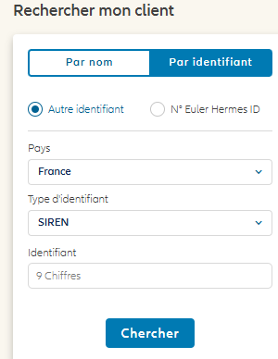
è Then Search
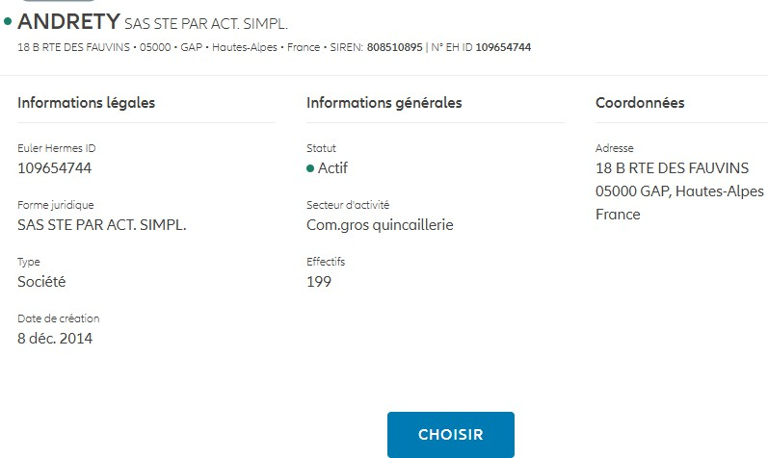
è Check Policy
è Make a new request

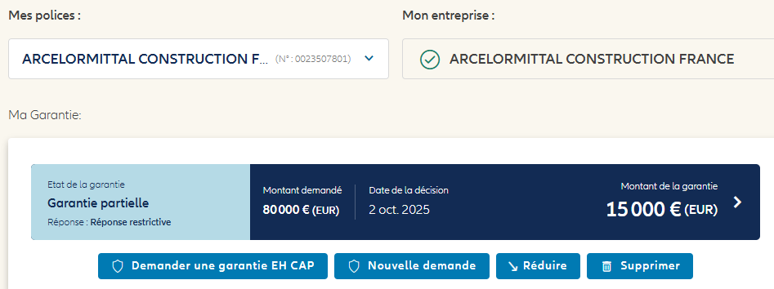

è Enter the desired amount, then the customer reference SOFIE + our initials
è Validate

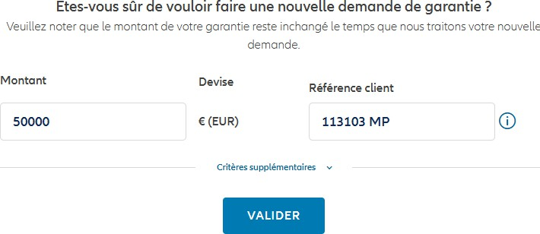

CREDIT APPLICATION WITH BALANCE SHEET

è Apply as above
è Take screenshot of current or declined application
è Send an e-mail to Pascal LEGATT, our broker
è Mention our contract number and the customer's ALLIANZ reference in the subject line
è Specify your needs

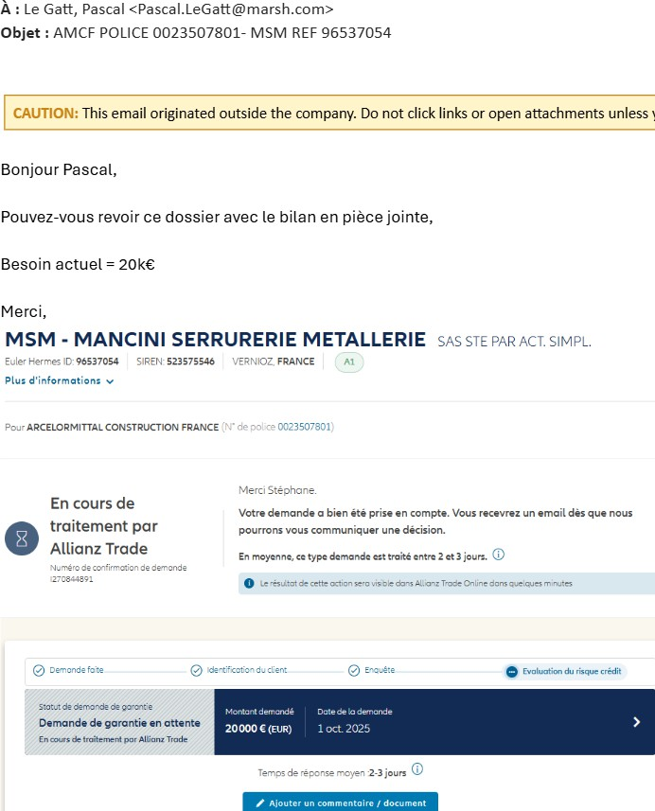
è Then send the e-mail

- CAP / CAP + CREDIT REQUEST
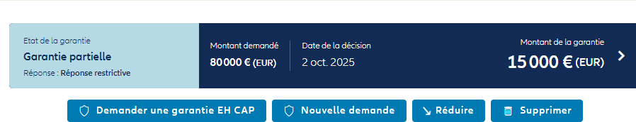

è Enter the desired credit
è Enter the SOFIE code and initials
è Then validate

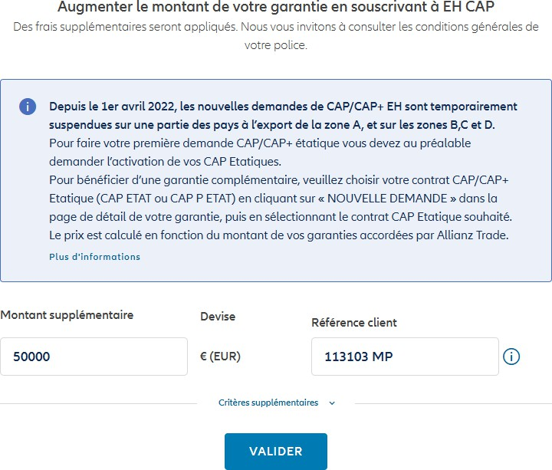

è Complete the CAP / CAP + table:

è Fill in all table columns
è This table is used by the CreditManager to monitor, control and validate invoices. It must therefore be updated systematically, and checked every day to update CAP / CAP+ in SAP.

EULER ENDORSEMENT

è Record the rider received in the customer credit mailbox as an attachment under the N in the customer's file
of the customer, in this example account 113103 and in the "Credits" and "Atradius" folder.
Format to be used: Endorsement YYYY/MM/DD amount accepted/refused/maintained

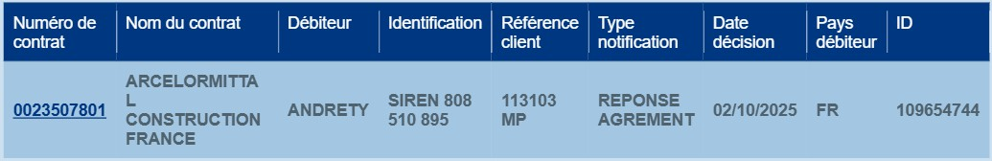
è Click on the contract number

è Download as PDF
è Save as N
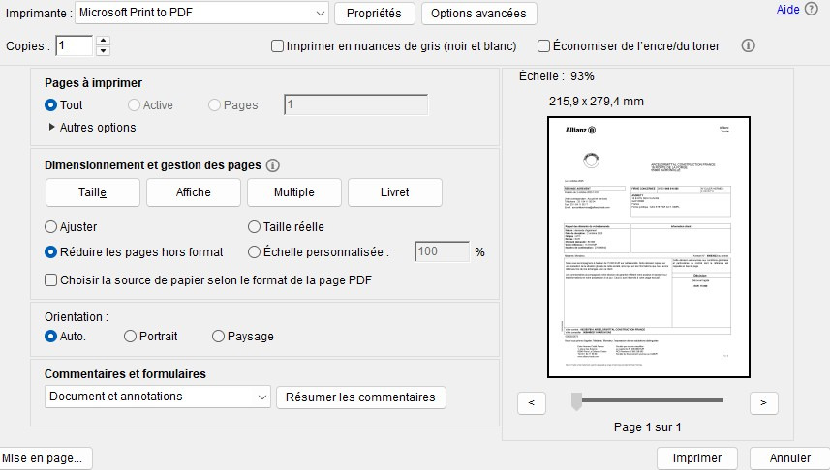

SOFIE COMMENT
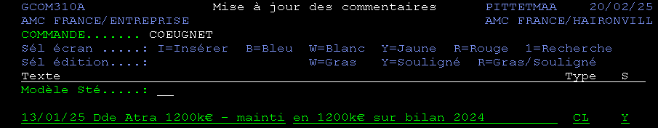
Go to Sofie 03-01-05-01, enter the customer's Sofie number. Then F10 to update the Sofie comment:

Format to be used: Date of comment, request at X with amount, accepted/refused/held, reasons
Blue B = application in progress
Yellow Y = decision received
Red R = credit modification/cancellation

On: 03/11/2025

Procedure validated by : S. HERNANDEZ

